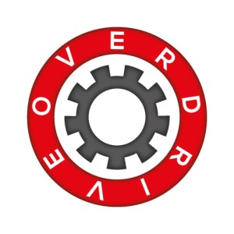
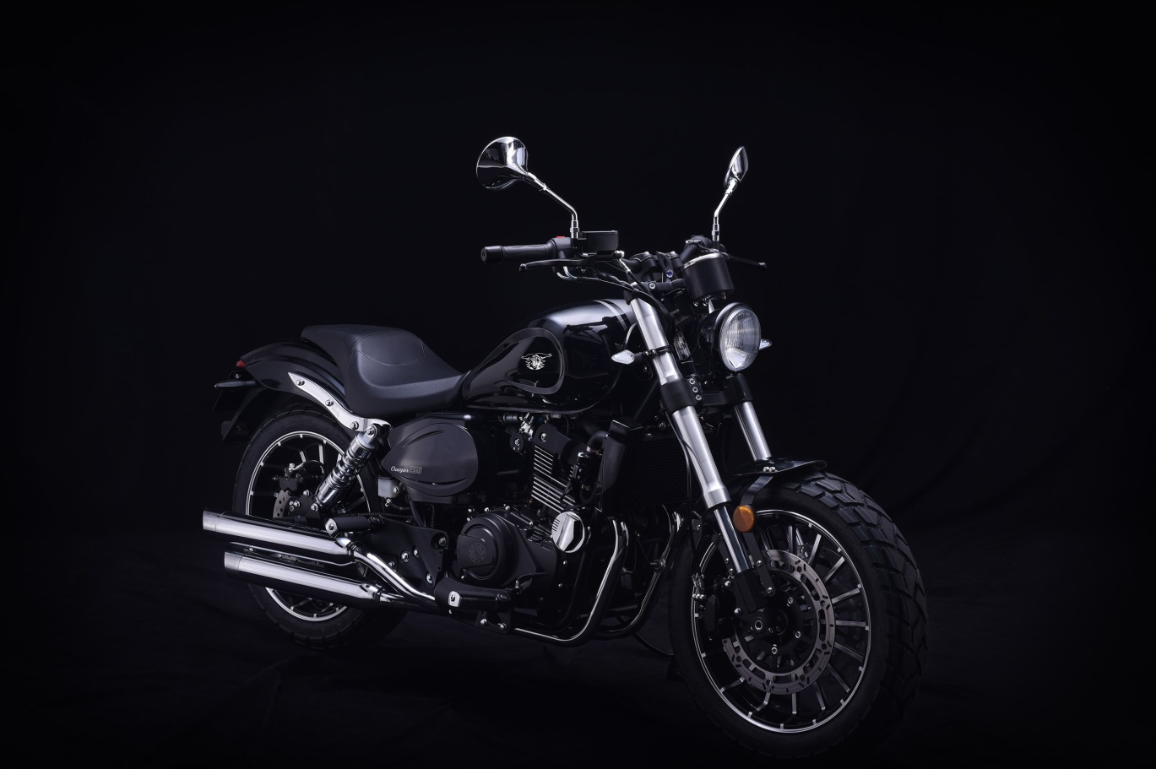
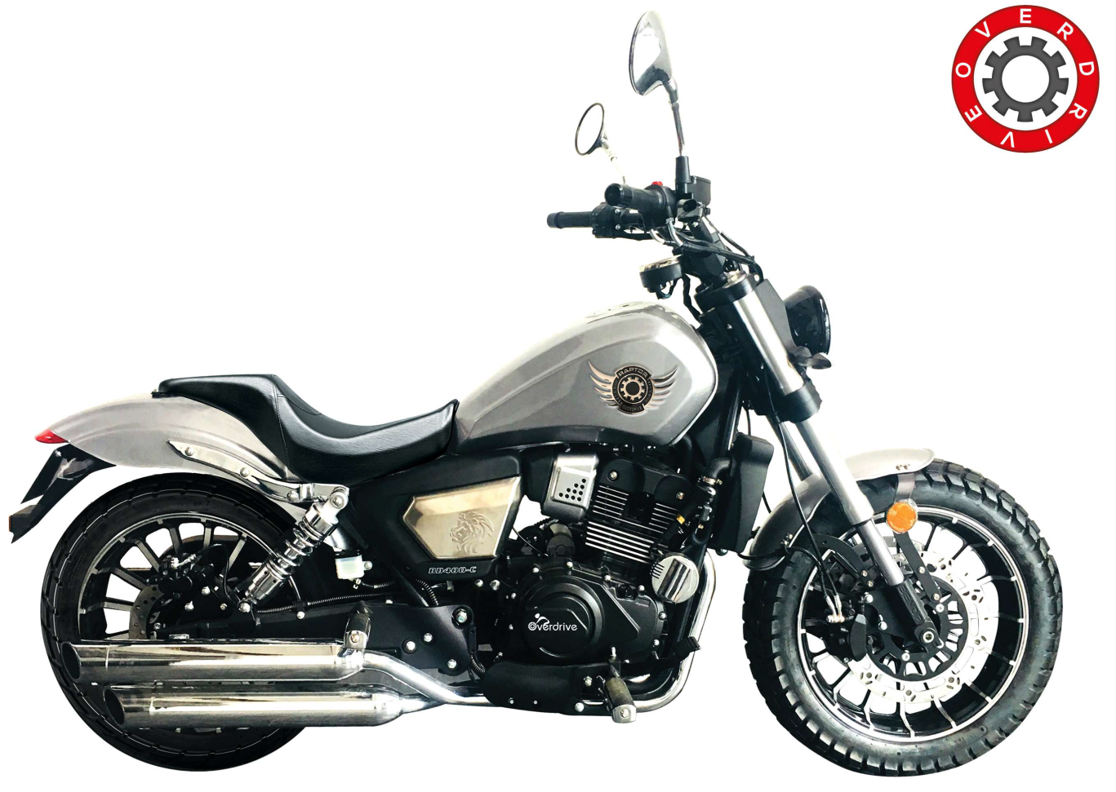
250cc Cougar & 300cc Raptor – EFI

USER
MANUAL

FOREWORD
Thank you for choosing the Overdrive motorcycle.
This manual describes in detail the basic operation and maintenance methods of the Overdrive 250CC, 300CC and 400CC two-wheeled motorcycles. Please read them carefully before driving.
Proper use, maintenance and maintenance can effectively protect traffic safety, maintain the best performance of the vehicle, and extend the service life of the vehicle.
The distribution unit has professional technicians who can provide the best repair and service for your motorcycle.
The data, specifications and descriptions indicated in this manual are based on the latest design of the company. Zhejiang Changling Benjian Motorcycle Co., Ltd. has the right to update at any time. In this regard, any changes to the technology of this vehicle in the future will not be announced.
I sincerely wish you a pleasant drive in the future!

ATTENTION
Please follow the traffic regulations and the use of this service instructions.
The use of maintenance manual is one of the essential attachments of the car. When the car is resold to others, please attach it with the car.
The use of this service manual is copyrighted by Zhejiang Changling Benjian Motorcycle Co., Ltd. and it is not allowed to reprint without the written consent of the company.
Danger/Warning/Attention
Please read the contents of this manual and keep in mind the essentials
Danger:
The term suggests that the driver’s personal safety is a concern and neglecting this term may result in injury.

Warning :
The words suggested by the indicating the relevant operational precautions to avoid damage to the motorcycle.
Attention :
The term suggested by the word is for the purpose of facilitating maintenance or making specific explanations of the important explanations more specific.

Contents
I.COUGAR and RAPTOR troduction to two-wheeled motorcycle····················································2
II.User notices ······························· ···················································· ········································5
III. Transportation, storage and unpacking of motorcycles························································6
IIII. Safe driving of motorcycles···································································································7
1. Safe driving rules······················································································ ···· ··············7
2. Safety protective equipment································································· ············ ··········7
3. Modification of vehicles····································································· ·······························8
4. accessory························································································ ··· ·······························8
V. Instructions···························································································· ····························· ··8
1.Parts location······································································· ··············· ··························10
2.Speedometer and ignition switch··························································· ·····························11
3.Left and Right switch·············································································· ··························12
4.Leftswitch combonation ························································ ····························12
5.Fuel and tank··························································································· ··························13
6.Tire········································································································· ··· ······················14
VI.Operation························································ ······························· ······································16
1.run-in-wear······················································································· ································16
2.Inspection before driving·················································· ········· ·································17
3.Start······································································· ························· ··· ·····················17
4.Drive·············································································· ·················· ························19
VII.Maintenance································································ ························································22
1. Maintenance schedule························· ··········· ·· ····················22
2. Inspection, selection and replacement of engine oil········· ··· ··························24
3. Selection and replacement of spark plugs·············································· ····························26
4. Air filter cleaning and disassembly························································ ·····························27
5. Check and adjust the throttle handle························································· ·········· ···········28
6. Clutch adjustment····················································································· ························29
7. Chain inspection, adjustment and lubrication ······························ ············ ·······29
8. Front brake inspection and adjustment·············································· ·······················31
9. Rear brake inspection and adjustment················································ ································32
10. Battery maintenance·········································································· ·······························33
11. Engine water cooling system maintenance instructions····················· ··········· ··················34
12. Vehicle cleaning and storage······························································· ······························36
13. Vehicle life and vehicle handling··························································· ·····························37
14. Motorcycle related adjustment data······································ ·········· ·····························38
15. Main technical parameter list······················ ··· ··············· ············38
16. Common faults and causes of motorcycles···················· ············ ············40
17. Electrical system diagram ······································· ······· ·········43

I、Overdrive two-wheels Motorcycle Introduction
Overdrive's two-wheeled motorcycle has a compact structure and a unique and innovative appearance. Riding comfort, driving stability, using electronic fuel injection system, more environmental protection, fuel consumption, low emissions, to meet the national emission requirements.
Overdrive motorcycle will bring you an unprecedented driving experience!
The application scope of Overdrive motorcycle
COUGAR and RAPTOR are two-wheeled motorcycle independently developed by Overdrive. It adapts to both urban and rural roads.
II. The characteristics of Overdrive motorcycle
1、Strong power, heavy load.
2、Large torque, strong climbing.
3、Electronic fuel injection system.
4、Adopted domestic advanced and professional water-cooled engines.
5、A "full DC power supply system" was used.

II、User notice
1, bearing provisions:
Carriage capacity: 2 persons (1 driver and 1 occupant).
Maximum allowable load: 150kg.
2. Fuel
Fuel brand: No. 95 unleaded gasoline.
Because gasoline is extremely flammable, if the fuel tank, fuel filter, oil pipe, throttle valve body and other parts of the vehicle have oil leakage due to damage and aging, they must be repaired before use.
Unleaded gasoline can extend the service life of spark plugs and mufflers.
3, electrical appliances
You cannot add or modify the line of your own vehicle, nor can you increase or add electrical equipment yourself. Otherwise, the electrical system may be overloaded, causing overheating of the circuit, melting of the fuse or short circuit of the circuit, or even sparking and danger of burning the vehicle.
Danger:
The company is not responsible for any consequences caused by adding or changing the line of the car or increasing or adding electrical equipment.

4, check
You should maintain the listed parts strictly in accordance with the requirements in the “Maintenance Periods”.

III、Transport, storage and unpacking of motorcycles

A. The motorcycle (with packaging box) should be firmly fixed on the transported vehicle. No bruising or damage may occur during transportation.
B. The motorcycle (with packaging box) should be stored in a clean, ventilated, dry, rainproof, and sunproof warehouse, and must not be stored together with flammable materials, chemical corrosion products, and other harmful items.
C. The motorcycle is installed at the dealer's office and is delivered to the user after normal debugging.
The installation order is:
1. Unpack the carton and take out all accessories and motorcycles.
2, the installation direction of the assembly and rearview mirror.
3, install the front wheel, front fender; remove the right guard, install the battery; install other accessories, tighten the bolts of the whole car, check the circuit and start the motorcycle.
4, adjust the light signal, before and after the brakes, clutch, throttle, etc., and test ride can be delivered to the user after the normal use, the installation is completed.
The three items of transportation, storage and unpacking of motorcycles are for dealers' reference only.

IIII、Safe driving of motorcycle
This motorcycle is a two-wheeled motor vehicle, which can bring convenience and speed to the rider. In order to ensure the best performance of your motorcycle, you must carry out proper maintenance and maintenance of the motorcycle. When you use a motorcycle, the vehicle must be safe and normal; when you drive or ride the motorcycle, the body must be healthy so that you can control the vehicle under optimal conditions.
Danger:
Driving a motorcycle must comply with traffic regulations; before driving, the vehicle must be carefully inspected.

1.Safe driving rules
1. Before starting the motorcycle, the vehicle must be inspected carefully to confirm that the vehicle is safe and normal. This will prevent accidents and damage to parts.
2. Motorcyclists must pass the examination of the traffic management department and obtain a “motorbike driver’s license”; motorcycles must not be used by anyone without a “motorbike driver’s license”.
3. To avoid causing harm, you should do:
● Wear eye-catching.
● Do not drive too close to other motor vehicles. Use signals such as turn signals, horns, and brake lights.
● Please do not drive in the blind spot of other driver's sight.
4, strictly abide by traffic laws and regulations.
● Speeding is the main cause of motorcycle accidents. If you encounter rain, snow, sand, roads, intersections and other road conditions, you must drive slowly or slowly.
● When turning and changing lanes, signal devices such as a turn signal must be turned on to attract the attention of other drivers.
5, the driver should grip the direction of the handlebars with both hands, feet on the front pedal; the occupant should hold the armrests or hands tightly hold the driver's waist, feet on the rear pedal.
2. Safety protective equipment
1. Most of the injured in motorcycle accidents are head injuries. Therefore, drivers and occupants must wear helmets that meet the safety and quality standards and wear protective equipment such as dustproof glasses and gloves.
2. When driving, exhaust muffler temperature is high. In order to avoid contact with burns, drivers and occupants should wear long boots and other equipment.
3. Do not wear loose clothing to prevent accidental hooking of the direction handles, clutch handles, ankles, or vehicles next to them.

3. Modification of the vehicle
note:
1. It is illegal to refit a motorcycle or change the device of the original car without ensuring the safety of the motorcycle. You must comply with the traffic regulations of the traffic management department.
2. In order to ensure that the emission of exhaust gas can meet the national emission requirements, you must not modify or remove the following components without authorization.
1) Do not adjust idle speed freely;
2) Since the exhaust muffler is equipped with an optimized catalyst, if the exhaust muffler is damaged, go to the designated maintenance unit for repair or replacement.
3. If there is a good suggestion for modification, the company can be informed and the company will be responsible for implementation after confirmation. The company will not be responsible for the adverse consequences of unauthorized modification.

Danger:
The company is not responsible for the dangerous consequences of your own modification of cables and appliances, resulting in a short circuit, a blown fuse, an electrical appliance that exceeds the rated power, or a spark that may cause burning.

note:
Improper loading or overweight of motorcycle cargo will damage the performance of the vehicle and affect the driving stability of the vehicle.

When loading cargo:
- The center of gravity (centres of gravity) of the cargo should be located low and near the center of the vehicle.
- Adjust the tire pressure according to the weight and driving conditions (see page 13).
- All goods must be firmly fixed in the vehicle to ensure stable operation.
- Can not be large, heavy objects tied to the steering handle, front shock absorber or front fender, otherwise it is easy to cause the drive is not smooth or steering ineffective.
- Do not exceed the maximum load requirement of the vehicle (150kg).
4. Accessory

The original accessories of the car have been tested by the company. Therefore, if you install non-original

Accessories caused by adverse consequences, the company will not be responsible.

After installation of non-genuine accessories, you must carefully check: sight obstruction, ground clearance, side tilt angle, steering mechanism steering flexibility, ease of operation, and accessory performance. If you have the above problem, you should cancel the attachment before you can use this car.

V、Instructions for use

1. Part location
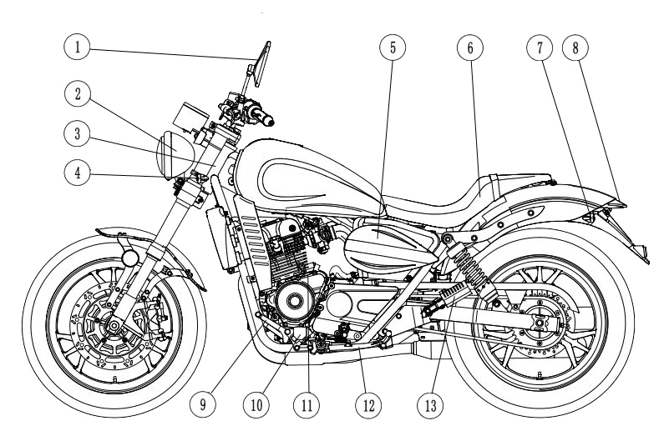
1、（figure 1）
1 left rearview mirror
2 headlights
3 vehicle nameplate
4 front left turn signal
5Air filter (inboard)
6 seat cushion
7 rear left turn signal
8 tail lights
9 shift lever
10 front left ankle
11 Engine number
12 single pole
After 13 left ankle figure 1

2, (Figure 2)
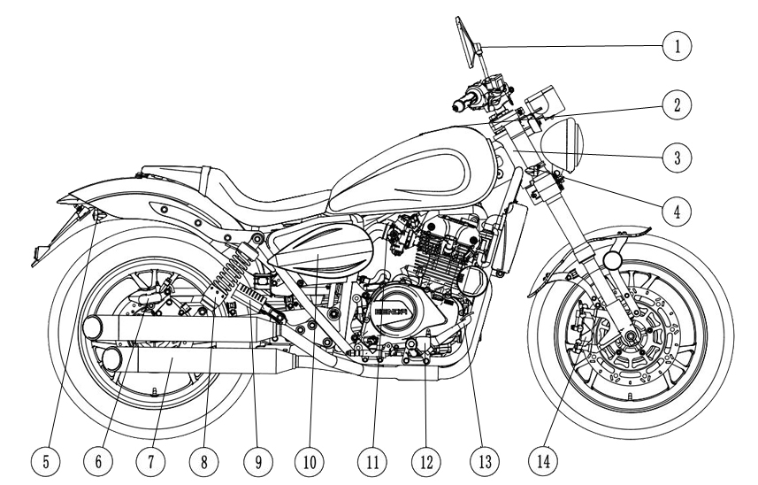
1 right rearview mirror
2 fuel tank cap
3 frame VIN code
4 front right turn signal
5 right turn signal
6 rear caliper
7 exhaust muffler
8 rear shock absorber
9 right rear feet
10 Battery (inboard)
11 throttle body
12 front right ankle figure 2

13 brake pedal
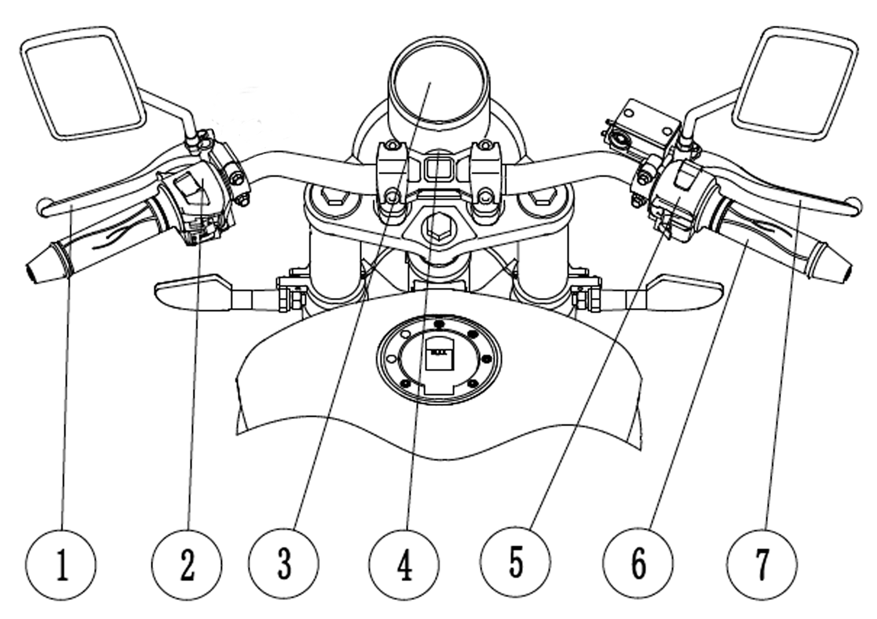
14 front caliper

3, the front body (Figure 3)
1 clutch handle
2 left switch combination
3 instruments
4 ignition lock
5 right switch combination
6 throttle grip
7 front brake handle
Figure 3

4, the nameplate, frame number (VIN), the engine number position (Figure 4)
1 frame number (VIN): right side of the head tube;
2 nameplate: head tube left side;
3 Engine number: Above the left crankcase.

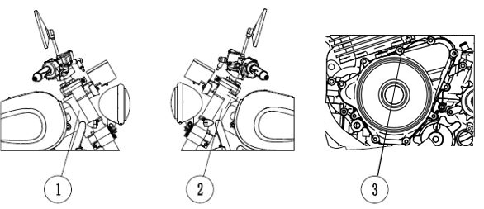

(Figure 4)

2. Meter and ignition lock
1, the instrument (Figure 5)
Refer to Table 1 for the names and functions of the indicator symbols.
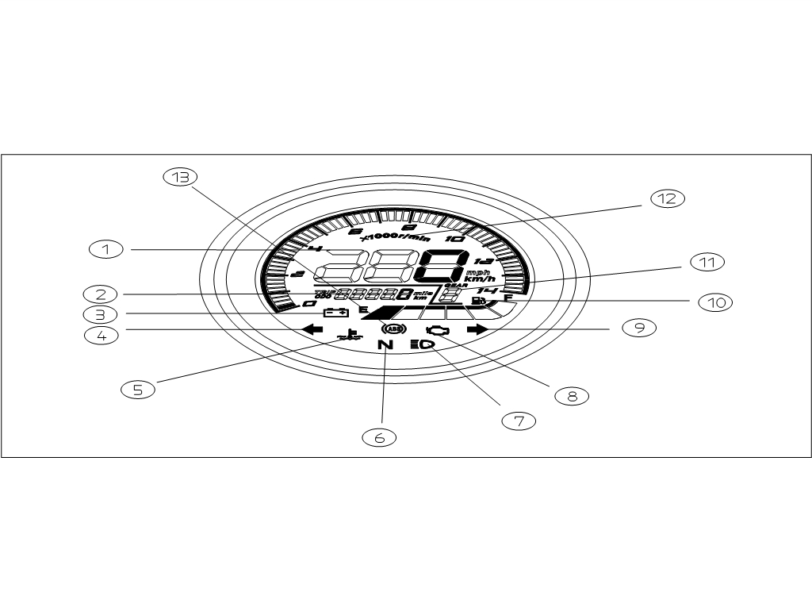
Figure 5

Table 1
Code Nu. | Name | Function
1 | Speed indication | The instantaneous speed of the vehicle
2 | Mileage indication | Total mileage traveled by the vehicle
3 | Voltage alarm indication | Lights red: battery voltage is too low
4 | Turn left | Front and rear left turn signals are on, showing green
5 | Water temperature alarm indication | Lights red: Coolant overheated, cooling system is faulty
6 | Neutral indication | Neutral light green when in neutral
7 | High beam indication | High beam lights, lit blue
8 | EFI failure indicator | The light goes out after the engine is running.
9 | Right turn indication | Front and rear right turn signals are flashing, lit green
10 | Fuel quantity indication | Shows the amount of fuel left in the tank
11 | Gear indication | Shows where the engine is located
12 | Speed indication | Display engine speed
13 | ABS instructions | Display ABS status

2、Ignition lock
The ignition lock is set in front of the direction and the ignition must be turned on before starting the motorcycle. Key location and function see table 2。
Key position | Function | Key status
off“” | The circuit is disconnected and the engine cannot start | Can be pulled out
on“” | Circuit is closed, engine can start | Cann’t be pulled out
Direction lock “” | Circuit is disconnected, locking steering mechanism | Can be pulled out
Attention：
1、When the vehicle is not in use, the key is turned off “” Or direction lock to“”，take off key。
2、Lock the steering mechanism: Turn the front end to the extreme left position.“” Press the key in position, let go and let the key bounce back, turn counterclockwise “”。
3、Before locking the steering mechanism, decelerate and stop, then park with a single pole; after locking, never drive the motorcycle, or you will lose balance.
TABLE 2

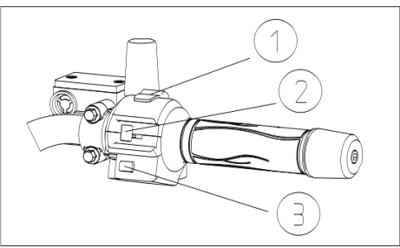
3.R&L switch combination
（Figure 6）
- Flameout preset switch
- Headlight, position light switch
③ Electric start button

1、Flameout preset switch

Flameout preset switch has two positions：“”and，When starting the motorcycle, this switch must be placed “”。
“”： Indicates that the starting circuit is open, the engine cannot start or the operating engine is off。
“”： Indicates that the starting circuit is closed and the engine can start.

1, headlights, position lights switch
Headlights, position light switches have three positions：“” “” “●”
“ ”： Headlights, position lights, and taillights are on。
“”： Position and taillights are on。
“ ● ”： Headlights, position lights and taillights are off。

3、Electric start button
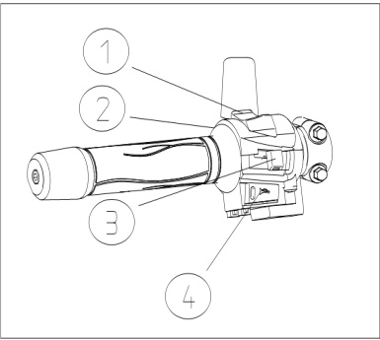
The operation method is: After completing the preparation for starting (see page 16), press the electric start button “ ”, if necessary, turn the throttle at the same time to set the sleeve properly, then start the engine.

D.Switch combination
（Figure 7）
1 headlamp dimmer switch
2 Override light switch
3 turn signal switch
4-horn button
Fig7 L&R switch combination

- Headlamp change light switch
Turn ignition switch lock and "Headlamp, position light switch" to “”：
"Headlight dimmer switch" to “” is low-beam
"Headlight dimmer switch" dialed “”is high-beam.

2. Override light switch
When the “override light button” is pressed, the overtaking light is on;
When the "override light button" is released, the overtaking light does not shine.
3, turn signal switch
When turning left, turn “turn signal switch” to “ ” position; left and right front and rear lights, and the left turn signal in the instrument panel lights up.
When turning to the right, turn the "turn signal switch" to the "" position; the front and rear lights on the right, and the right turn indicator light in the instrument panel lights up.
Turn the "turn signal switch" to the "middle" position; the left and right turn lights and lights are off.
Warning:
The turn signal switch must be turned on when a turn or lane change is to be made, and the turn signal switch cannot be turned off until the turn is completed or the lane change is completed.

4, Horn button:
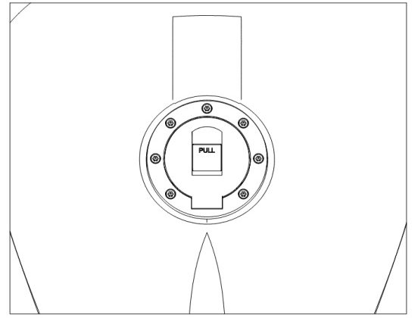
Press the “horn button” and the “trumpet” will continue to buzz; release the button, the button will return to its original position, and the “horn” will stop buzzing.

5..Fuel and fuel tank cap
1, fuel
The fuel used by this vehicle is: No. 95 unleaded gasoline.
Figure8.tank cover
- Fuel tank cover opening method (Figure 8)
Open the small cover covering the keyhole, insert the key into the lock hole of the fuel tank, and turn the clockwise direction to open the fuel tank lock; when it is closed, pull out the key, gently close the fuel tank cover, and press firmly until you hear the “click” sound. can. Finally cover the small cover that covers the keyhole.

Warning:
In order to prevent the fuel from running out and cause sudden stoppage and protect the fuel pump, fuel should be added in time when the indicator of fuel consumption of the meter is near point E.

6.Tyre
The correct tire pressure will ensure: stable driving, comfortable driving, and durable tires. Tyre pressure should be checked at "cold tires".
Tire specifications and tire pressure refer to Table 3:

Tyre pressure in cold state | Single Ride |  |  | Double Ride
Tyre pressure in cold state | kPa | kgf/cm2 | psi | kPa | kgf/cm2 | psi
Front wheel | 225 | 2.25 | 33 | 225 | 2.25 | 33
rear wheel | 225 | 2.25 | 33 | 225 | 2.25 | 33

Figure 3

Tire condition and specifications (Figure 9)
Incorrect tire conditions and incorrect tire specifications affect the handling performance of motorcycles. Damaged scratches on the tire can cause the tire to fail and cause the vehicle to lose control. Excessively worn tires can perforate the tire and cause the vehicle to lose control. Tire wear also affects tire shape and handling performance.
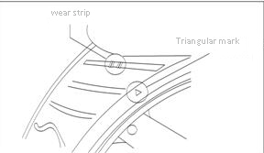
Check the condition and pressure of the tire before use every day. If there is a lot of obvious damage on the tire, such as: damage, scratches, or tire wear to the extreme position, you must replace the tire.

Attention:
1. When the tire pressure drops, check whether there are nails or holes in the tire and whether the side of the rim (rim) is damaged. Tubeless tires gradually deflate when they have small holes.
2. Incorrect tire pressure can cause abnormal tread wear, as well as safety accidents. 3, insufficient tire pressure can cause the tire to be damaged or get out of the rim.

Attention:
1. The triangle mark indicates the position of the wear bar. If the wear bar comes into contact with the ground, it means that the tire has worn to the limit. The tire must be replaced.
2. When changing tires, make sure that the size and type of tires to be replaced should comply with Table 3. If you change the tires of different sizes or different models, it will affect the handling performance of the motorcycle and may cause the motorcycle to lose control.
3, after repairing tires or changing tires, balance the wheels. It is important to balance the wheels correctly to avoid uneven contact between the tires and the road surface and to avoid uneven tire wear. balance the wheels correctly to avoid uneven contact between the tires and the road surface and to avoid uneven tire wear.

·

Danger:
1. Tubeless tyres are sealed at the rim and bead contact portions. In order to avoid air leakage, the removal and installation of tubeless tires requires special tools to protect the rim and bead parts, using a special tire changer.
2. To repair the hole in a tubeless tire, remove the tire and apply a patch inside the tire. Do not use external repair methods because the tire's centrifugal force will loosen the repaired area when turning. After 24 hours of tire repair, the vehicle speed must not exceed 80 kilometers per hour, and the vehicle speed cannot exceed 130 kilometers per hour. If the speed is exceeded, the tire's calorific value increases sharply, making the repair ineffective and causing the tire to leak. If the side of the tire is damaged or the tire is broken more than 6 mm, the tire cannot be repaired.

VI.Operation

A. Run-in period

The run-in period refers to a treatment method that the new car will use to ensure that the interface between the part and the part becomes the best combination during the initial distance.
The mileage of the new vehicle during the run-in period is 1500 km.

note:
1. During the running-in period: The throttle should be prevented from full open operation, and the maximum engine speed cannot exceed 6500 rpm (see instrument).
2, each stall should be used.
3. Do not drive the vehicle at a fixed throttle position.
4, do not load too much (more than the maximum load).
5. Replace the oil three times.

1, the operating mode of the run-in period
1) 0 to 300km run-in:
The throttle handle should be opened to avoid exceeding the maximum opening 1/2; speed within 50km/h.
2) Running at 300 to 600km:
The throttle handle should be opened to avoid exceeding the maximum opening 2/3; the speed should be within 60km/h.
3) Running at 600-1500km:
The throttle lever should be opened to avoid exceeding the maximum opening 3/4; speed is less than 70km/h.

2. Replace the lubricant three times during the run-in period
Replace the lubricant within 1500km of the run-in period and replace it every 3000km.
Attention:
If the engine malfunctions during running-in, consult the Overdrive Store immediately for inspection or repair

2. Inspection before driving
In order to ensure the safety of driving, please check your vehicle carefully before using the motorcycle. If there is any abnormality in the inspection, you must use it before repairing.
Checks can follow the following procedure:
1, check the engine oil (see page 21), and ensure no leakage;
2, check whether the fuel is sufficient;
3. Check whether the coolant in the cooling system is sufficient and ensure that there is no leakage;
4, check the front and rear brakes: free stroke (before 5-10mm, after 10-20mm), smooth operation;
5, check the front and rear tires: air pressure, wear depth of the tread pattern, cracks (see page 13);
6, check the chain: elastic fit (upper and lower clearance 10-20mm), lubrication conditions are good;
7, check the throttle handle: free clearance (2-6 mm), refueling or return oil is easy to operate;
8, check the lights and lights: to ensure that headlights, taillights, brake lights, turn signals, lights, horns are in good condition;
9, check the battery electrolyte, add distilled water in time (see page 30);
10, inspection steering device: should be smooth, flexible rotation, no loosening and axial turbulence;
11, check the clutch handle: free clearance (5-10mm), smooth operation;
12. Fastening bolts and nuts: front and rear shock absorbers, flat fork shafts, front and rear wheel axles, engine suspension, steering systems, steering handles, front and rear brakes, clutches, rear suspension systems, electrical components, and more.

3.Starting of motorcycles (Figure 10）

1. Turn on the ignition switch lock and turn off the preset switch to the “” position.
2、Change the gear position to low gear or neutral.
3、The left hand fully grips the clutch handle (when the non-neutral state is released, the clutch is disengaged).
4. Press the electric start button “ ”. If necessary, turn the throttle handle to refuel properly to start the engine.
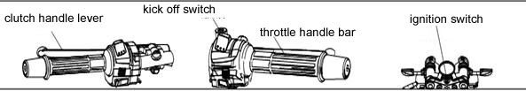

Figure 10 Start preparation
Danger:
1. In order to avoid mistakes, it is dangerous to rush forward when starting. Hang the neutral gear and do not add the throttle.
2. When not driving, the engine speed should not be too high, and the idle time should not be too long, otherwise the engine will overheat and damage the internal parts, and the exhaust pipe muffler will change color.

Danger:
1. If you are driving this model for the first time, we recommend that you find a non-public road practice until you are familiar with the control method and operation method of the car.
2, one-handed driving is the most dangerous, should hold the direction of the hand firmly, feet on the ankle. In any case, do not leave your hands.
3. Reduce the speed to a safe speed before turning.
4, the road surface is damp and smooth, the tire friction is small, the braking capacity and turning ability are naturally reduced, so it must be decelerated in advance.
5. Crosswinds are usually most likely to occur when tunnel exits, valleys, or large vehicles are overtaken by the rear. You must be careful and slow down.
6. Obey traffic rules and speed limits.

note:
1. After starting, it should be preheated for 2-3 minutes before driving on the road. Engines with insufficient preheating temperatures can exacerbate wear on cylinders, piston rings, rocker arms, etc. while driving.
2. When using the electric start button “ ”, each operation should be released within 3 to 5 seconds immediately; otherwise, it will easily cause the battery to discharge too fast and affect the service life of the battery.
3. After the engine is started, the electric start button “ ” should be released immediately; during the engine running, it is not allowed to press the electric start button “ ”, otherwise the engine will be damaged.
4, to ensure that the single support is fully retracted, to avoid driving hindered and control failure when turning left.
5. Stabilize after starting or during driving (turn the throttle handle).
6, do not start the motorcycle in a small space, to avoid the discharge of exhaust gas is not easy to spread and poisoning.
7. If the clutch switch fails, it should be replaced in time.
8. It is strictly forbidden to start the engine when the clutch is not disengaged, otherwise it will cause damage to parts or safety accidents.
9. Do not start the motorcycle when fuel or oil is missing.

4.Drving
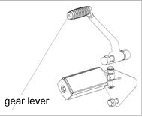
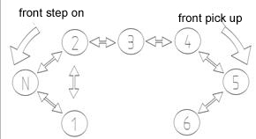

Figure 12 gear lever
Figure 11 Shift position drawing

1. Shift operation (Fig. 11, Fig. 12)
The motorcycle is always engaged in six gears; ①② gears are low speed, the third and fourth gears are medium speed, and the fifth and sixth gears are high speed. To change gears, please refer to the following operations:
1) Change to 1st gear: Return the throttle to the right hand, quickly grasp the clutch handle with your left hand, and step on the shift lever with your left foot to make the transmission enter the 1st position. The left hand gradually releases the clutch handle, and the right hand gradually increases the throttle. The action cooperates with the coordination to make the motorcycle run smoothly in the first gear.
2）1st gear change 2nd gear: The right hand returns to the throttle, the left hand quickly grips the clutch handle, and the left foot hooks up twice to shift the lever, so that the transmission enters the 2nd gear position, the left hand gradually releases the clutch handle, and the right hand gradually increases the throttle. The action is coordinated and coordinated, so that the motorcycle runs smoothly in the second gear.
3）The method of changing 3, 4, 5, and 6 gears in 2 gears is the same as the method of shifting 2 gears in 2 gears.
4）The method of lowering the gear position is the same as the method of changing the gear position.

Warning:
1. It is strictly forbidden to shift gears when the throttle is not returned and the clutch is not gripped, otherwise the engine and transmission system may be damaged and a safety accident may occur.
2. When changing gears, please confirm that the shift lever has been stepped in, and then release the clutch handle.
3. During the shifting of the clutch handle during the shifting, the clutch is disengaged and the motorcycle is driven by inertia. Therefore, the shifting time should be shortened as much as possible.
4. When the vehicle is suddenly lowered at high speed or the throttle is suddenly returned, the engine speed is lower and the rear wheel speed is higher. When the clutch handle is released, the friction plate of the clutch plate is decelerated to cause the rear wheel brake, and the loss of control causes an accident. Therefore, when driving at a high speed for low speed, you must use the brake to slow down and then lower the gear.
5. It is strictly forbidden to use high-speed driving at low speed. It is strictly forbidden to use high-grade low-speed driving, otherwise the engine will be damaged.
6. Before the acceleration, the high-end position must be raised to make the engine run within the normal speed range. No gear can make the engine speed too high.

note:
1. Reduce the speed of the vehicle or increase the speed of the engine before changing the lower gear. Increase the speed or reduce the engine speed before hitting the high gear. This protects against the necessary wear of the drive train components and the rear tires.
2. When the gear is in neutral and the neutral indicator is lit, it is best to slowly release the clutch handle to confirm whether it actually enters the neutral position.

2. Climbing or turning (Figure 13)
1）When driving uphill, the gear will be too high and there will be a deceleration of insufficient power. Therefore, you must quickly lower the gear before going uphill
2）The gear must be lowered when driving down the long slope, and the front and rear brakes should be used intermittently. If the front and rear brakes are used for a long time, the brake will overheat and the braking effect will be reduced
3）Do not turn off the ignition switch or turn off the engine flameout switch when going downhill, otherwise it will reduce the life of the catalyst in the exhaust muffler.
4）Before turning, you must use the brakes to lower the speed and then lower the gear. Otherwise, the vehicle will rush out of the corner when turning, or use the brakes when
cornering to cause a dangerous accident.
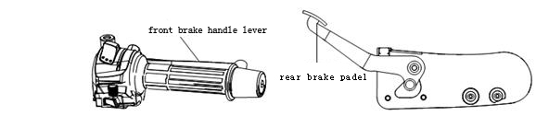
Fig 13 brake position

3, Brakes
1) When deceleration is required, the front and rear brakes must be used at the same time. (The right hand slowly grips the front brake handle, and the right foot slowly steps on the rear brake pedal to avoid separate use of the front and rear brakes). Avoid slowing down too much and causing the clutch to slip
2) In case of emergency danger, directly turn off the flameout switch and use the front and rear brakes to stop.
3) Try to avoid sudden braking. Because the sudden braking will cause the front and rear wheels to suddenly stop, making the vehicle difficult to control.
4) Avoid sudden acceleration, sudden braking and sharp turns on slippery or soft surfaces. Prevent the vehicle from slipping and difficult to control.
4, parking
1) Gradually return to the throttle to make the throttle fully return.
2) While holding the front brake handle slowly with your right hand, slowly press the rear brake pedal on your right foot to avoid using the front and rear brakes separately.
3) When the vehicle speed decreases, lower the gear position.
4) Grasp the clutch handle, hang in the neutral position and then stop completely. The neutral indicator on the meter lights up when the neutral is engaged.
5) If you want to park on a gentle slope with a single support, you should hang the low gear and the front of the car is uphill to avoid overturning. (Be sure to hang in the neutral position when starting again)
6) Turn off the ignition switch lock; in an emergency, directly turn off the flameout switch to turn off the engine.
7) Lock the steering mechanism and remove the key to prevent theft.

Danger:
1. The higher the speed, the longer the braking distance will be. Therefore, it is necessary to maintain a safe distance to prevent rear-end collision. (Often only using the rear brake will accelerate the brake system and the braking distance will be longer and longer)
2. Only use the front brake or rear brake to cause slippage and loss of control; on wet roads and runners, the brake system must be used with caution; emergency braking on uneven roads or smooth roads will cause the motorcycle to lose control.

VII Maintenance

1.Maintenance schedule
Maintenance times  Maintenance item | Maintenance cycle |  | Odometer km (Note 2)
Maintenance times  Maintenance item |  |  | 1000km | 4000km |  | 8000km |  | 12000km |  | Remarks
★ Fuel tank, oil pipe |  |  | Damage or aging should be repaired or replaced in time |  |  |  |  |  |  | Using before
★throttle |  |  | I | I |  | I |  | I |  | Using before
★ Cooling fluid |  |  | Change every 2 years |  |  |  |  |  |  | Using before check
Air filter element | remark① |  | 40 hours per drive or 1000km/I; 80 hours per drive or 2000km/C; 20,000km/R per trip
Spark plug |  |  | 2000km or 80 hours/I per trip; 6000km/R per trip
Engine oil | Replace the new car once at 1500km, and replace it every 3,000km or so.
Lubricating oil filter | Replace the new car once at 1500km, and replace it every 3,000km or so.
Chain\sprocket | remark① | I, L for every 500km
★ Brake lining |  | I travel every 1000km I, if necessary R
★★ Brake oil |  | Change every 2 years
★★ Front and rear brake system | remark③ | I |  | I |  | I |  | I |  | Using before
★switch |  | I |  | I |  | I |  | I |  | Using before
★Lights, speakers |  | I |  | I |  | I |  | I |  | Using before
★battery | Every month | I |  | I |  | I |  | I
fuse |  | I |  | I |  | I |  | I
Connection line |  | I |  | I |  | I |  | I
★Valve clearance | remark③ | Initial: 20 hours or 200km/I; 2000km or 80 hours per trip/I
★cultch |  | 2000km or 80 hours per trip / I |  |  |  |  |  |  |  | Before using
★ Suspension System |  | I |  |  | I |  | I |  | I
★ Fastening of nuts and bolts |  | I |  |  | I |  | I |  | I | Before using
★wheel |  | I |  |  | I |  | I |  | I | Before using
★★ Steering handle bearing (direction column thrust bearing) | remark③ | I |  |  | I |  | I |  | I
★★ Engine overhaul | remark③ | I |  |  | I |  | I |  | I
The motorcycle should be regularly maintained according to the time and mileage specified in Table 4. The vehicle must be cleaned before maintenance.
Table 4
The symbols in the above table are: “I” for timely inspection, cleaning, adjustment, lubrication or replacement; “C” cleaning; “R” replacement; “L” lubrication.
No ★ The project is maintained by you, or you can go to the Overdrive store for maintenance.
A ★ project is maintained by the staff of the Overdrive store; if you have special tools, spare parts or repair capabilities, you can also repair it yourself.
Two ★ ★ projects, for driving safety, can only be maintained by the staff of the Overdrive store.
Remark 1 indicates that the cleaning cycle should be shortened when driving in dusty areas.
Remark 2 indicates that when the odometer reading exceeds the highest number in the table, the maintenance cycle is repeated according to the mileage specified in the table.
Remark 3 indicates that maintenance adjustments can only be made by personnel at the Overdrive store.

2.Inspection, selection and replacement of engine oil
The effect of lubricating oil on the engine: reducing friction, increasing seals, cooling parts, cleaning parts and rust prevention.
If the quality of the lubricating oil is poor, the use time is too long, or the amount of lubricating oil is insufficient, it will accelerate the wear of the engine parts and reduce the service life of the engine; even cause the engine temperature is too high, the clutch wears or burns out, the power drops, the abnormal sound, the lubricating oil etc.

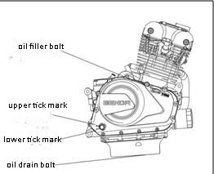
[check] （Fig 14）
The level of the lubricant must be checked before each use and the oil window is placed on the right crankcase cover.
Start the engine and run for 3 minutes, and the engine is turned off for 3 minutes. Park the motorcycle on a level surface and the vehicle is perpendicular to the ground. At this time, the oil level should be between the oil window and the lower scale line.
If the lubricating oil is insufficient, directly open the filler plug and add an appropriate amount of lubricating oil. Check for leaks after installing the filler plug
Fig14 Lubricating oil inspection
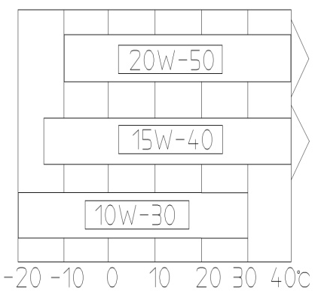
[ Selection ]（Fig 15）
Lubricant grade: SG 15W-40
Lubricant quality requirements: SG grade or above
Use high quality four-stroke engine oil to extend engine life. You need to choose according to Figure 15 according to the local temperature conditions:
When the local temperature rises, you should replace the high viscosity lubricant, such as SAE15W-40;
When the local temperature is lowered, you should replace the low viscosity lubricant, such as SAE10W-30.
SG | SAE10W-30
SG | SAE15W-40
SG | SAE20W-50
Fig 15
Lubricating oil inspection

Chart 5
Warning:
1. The use of inferior lubricating oil will seriously affect the performance and life of the engine.
2, long-term non-changing lubricants will deteriorate, deteriorated lubricants will cause excessive wear of the engine and parts.
3. If the lubricating oil is insufficient, the engine will be seriously damaged.

[Change]
The lubricant is completely replaced within 1500km of the new car running-in period; after the running-in period, it is replaced every 3,000km.
1. After the engine runs for 3 minutes, turn off the flame and place a oil container under the engine oil drain bolt.
2. Discharge the engine oil after 3 minutes (caution: do not get burnt by the engine or lubricant). Unscrew the oil bolt, loosen the 3 nuts, and remove the filter cover, spring, filter, etc.
3. After draining the oil, the oil drain bolt and the filter cover must be cleaned; replace the filter element and check whether the seal ring is intact. If it is damaged, replace it with a new one; then install the filter element, spring, seal ring and machine filter cover.
4. Inject about 2.1L of new lubricating oil from the filling port. If you replace the new filter element, you need 2.3L new lubricating oil, check and confirm that there is no oil leakage, and then install the filler plug.
5. Run the engine at different speeds for 3 minutes. During operation, check for leaks in the disassembled parts. Wait for the engine to stall for 3 minutes. In the idle state, the oil level is still lower than the lower line of the oil window, and an appropriate amount of lubricating oil should be added. It is necessary to check again for leaks.
Reasons for common lubricant deterioration:
1. The lubricating oil temperature is too high and naturally deteriorates.
2. The lubricating oils with different labels are added together and deteriorated.
3. There are more and more metal chips generated by friction of the parts.
4. There are many dust impurities in the lubricating oil barrel.
5. The gap between the piston and the cylinder is excessively leaking, and the carbon residue is generated when the fuel is burned.

Danger:
1. The exhaust pipe of the engine oil and muffler will burn people. Wait for the oil drain bolt and exhaust pipe to cool before draining the old oil.
2, children and pets if you accidentally drink oil will cause physical harm. Reiterate that long-term exposure to lubricating oil can cause skin cancer. Short-term exposure to lubricating oil can irritate the skin. Keep children and pets away from lubricants. When changing the lubricant, wear long-sleeved clothes and protective gloves (such as gloves for washing clothes) to reduce skin irritation. If the skin comes in contact with the oil, wash it thoroughly with soap and water. Clean clothes and rags that are stained with oil.

Warning:
If the specified engine oil is not used, the engine may be damaged.

note:
Please dispose of the used engine oil properly, do not pour it into the garbage can or pour it directly onto the ground to avoid polluting the environment. We recommend that you put waste oil in a sealed container and send it to your local recycling center.

（III）Selection and replacement of spark plugs
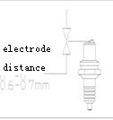
3.Selection and replacement spark plug （Fig 16）
Spark plug type：TORCH D8RTI
Spark plug sleeve opposite：16mm

[Check and replace]
1. The replacement period of the spark plug is about 6000 km.
2. Remove the spark plug cap, remove the dirt around it, remove the spark plug with the spark plug socket wrench in the tool bag, and use the wire brush to remove the carbon deposit and dirt from the spark plug.
3. Check the spark plug for damage, whether the electrode gap is ablated, whether the gasket is intact, and if it is damaged, it should be replaced.
4. Check the electrode gap with a thick gauge. The normal electrode gap is 0.6-0.7mm.
5. When installing the spark plug: firstly screw the spark plug into the thread by hand, then tighten it with a spark plug socket wrench.

Warning:
1. The dirt will enter the engine through the spark plug mounting hole, which will damage the engine. After removing the spark plug, you must cover the spark plug mounting hole with something.
2. If the color of the spark plug electrode is different from the normal spark plug, the new spark plug of the same type must be replaced. Different types of spark plugs have different heating values, which can cause serious damage to the engine. This loss cannot be claimed.
3. If the torque of installing the spark plug is too large or the thread is disordered, the engine cylinder head will be seriously damaged. Therefore, the spark plug must be carefully installed by hand

4.Air filter cleaning and disassembly
[Cleaning or replacing]
1. The filter element of the air filter must be periodically scheduled for maintenance: every 40 hours or 1000km must be inspected, cleaned and adjusted in time; the air filter must be cleaned every 80 hours or 2000km; every new drive must be replaced with 20,000km Filter element.
2. If the motorcycle is used in a muddy, humid or dusty environment, the period of cleaning or replacement of the filter should be shortened.
3. If the filter element is too dirty, water or damaged, a new filter element must be replaced. Otherwise, the intake resistance will increase, the engine output will decrease, and the fuel consumption will increase. Keeping the air filter clean can increase engine efficiency and extend engine life.
4. This motorcycle is a paper filter. When cleaning, you can gently squat on the ground to shake off most of the dust. If there is an air pump, you can blow it from the inside out and blow off the dust. If the filter paper is ash-permeable or The filter paper is wet with oil, water, etc., and a new filter element must be replaced.
5. During regular maintenance, remove the oil pipe and discharge the waste oil inside. The oil accumulation pipe is located below the air filter.
[Disassembly]（Fig 17）
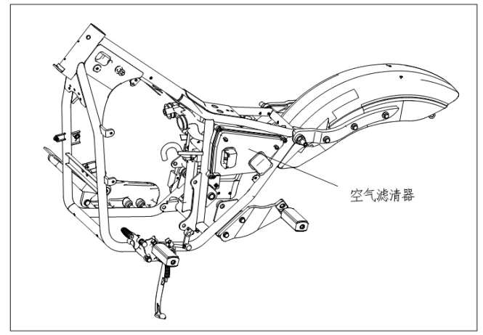

图17 空气滤清器位置

1. Disassembly: Remove the left side guard plate of the seat cushion, then remove the 4 screws of the air filter side cover, take out the card spring, and then slowly take out the filter element.
2. Assembly: Perform in the reverse order of the above disassembly steps.
Warning:
1. It is dangerous to start the engine without the filter element installed. Without the blockage of the filter element, the flame of the engine will be sprayed back from the engine to the air filter inlet, and dirt will be sucked into the engine interior, causing severe wear on the engine. Therefore, it is forbidden to start the engine without the filter element installed.
2. When flushing the motorcycle, do not allow water to enter the interior of the air filter.
3. If the filter element is damaged, a new filter element must be replaced. When cleaning the air filter, it must be checked whether the filter element is damaged.
4. If the filter element is installed in an incorrect position, dust will enter the engine around the filter and damage the engine. Make sure the filter element is installed in the correct position and sealed properly.

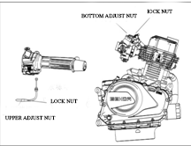
5.Check and adjustment of the throttle handle
[Check]（Fig 18）
1. Check if the front of the car is normal from the left to the right, and whether the limit is reliable.
2. Check if the rotation of the throttle control handle is flexible from the fully open position to the fully closed position; whether it can automatically return when the handle is released.
3. Check if the throttle cable is flexible and good.
Fig 18 Throttle handle and throttle cable

[Adjustment]
1. The free stroke of the throttle handle is: 2~6mm.
2. The upper adjustment screw can be fine-tuned, and the lower adjustment screw (the throttle and throttle cable connection) can be adjusted for a certain stroke.
3. When fine-tuning, first loosen the lock nut 2 on the upper adjustment screw, and then turn the upper adjustment screw 1 to adjust.
4. When making a large-scale adjustment, loosen the 4 fastening nut and adjust the free stroke to 2~6mm.
5, the throttle cable should be regularly filled with lubricating oil to reduce the wear of the wire rope; can not bend the throttle cable.

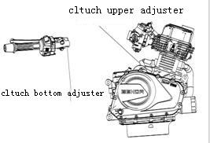
6.Clutch adjustment
The clutch stroke is free from 5 to 10 mm.
The role of the clutch: (Figure 19)
1. The engine crankshaft and the variable speed transmission system can be combined smoothly and gently to ensure the smooth start of the motorcycle.
2. The engine crankshaft and the variable speed drive system can be quickly and completely separated to ensure that the motorcycle does not have an impact when shifting gears.
3. It can prevent the parts of the variable speed drive system from being damaged due to excessive load.
Figure 19 clutch
When using the clutch handle, you should fully grasp or fully release; try to avoid only half or only half (use half clutch), otherwise it will cause the clutch to wear or burn.

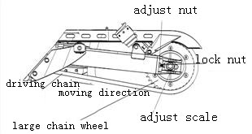
7.Chain inspection, adjustment and lubrication
Chain model: GB/T14212 520MH
Number of chain links: 112 knots [CHECK]（Fig 20）

The life of the chain depends on good lubrication and proper adjustment. Neglecting the maintenance and maintenance of the chain will result in premature wear of the chain and sprocket. Therefore, the chain must be maintained on a regular basis. If the chain, large sprocket and small sprocket reach the wear limit, they must be replaced in time.
Fig 20 chain adjustment
1. Change to neutral, the engine is turned off, and the vehicle is parked on a level surface.
2, swing the chain up and down, measure the swing amplitude, the normal range of swing: 10 ~ 20mm.
3. Check if the locking clip at the chain joint is loose or not, and whether the large and small sprocket are in the same plane.
4. Check the wear of each link of the chain. If the link is defective, the wear is too large, and the chain is too long, it must be replaced.
5. Check the wear of the small sprocket and the large sprocket. If the gear teeth are seriously worn, there are missing teeth and broken teeth, they must be replaced.

- send feedback
- History [lubrication]
3. Clean the chain, large sprocket and small sprocket. After cleaning, add proper amount of oil or spray clean lubricating oil.
2. Wash and lubricate once every 500km.
3. After driving for 3000km, the chain should be removed and cleaned once, and immersed in heated molten graphite grease for 5 to 10 minutes.
4. When the vehicle is driving on the plaster road, it is necessary to clean the dust in the chain section in time and add lubricating oil.
[Adjustment]
1. The chain must be adjusted regularly. If the chain is too loose, it will swing up and down and left and right when driving, and it is easy to drop the chain, chain or break.
2. Change to neutral, the engine is turned off, and the vehicle is parked on a level surface.
3. Loosen the rear axle nut, loosen the lock nuts on the left and right sides, and then tighten the adjustment nuts on the left and right sides to make the chain adjuster's scale line symmetrical, and make the chain swing between 10 and 20mm. Then tighten the rear axle nut and tighten the lock nut. Rear axle nut torque 65 N• m.
[replace]
1. Carefully remove the chain locking clip with a needle-nosed pliers, disassemble the chain link, and remove the chain;
2. Use tools to remove large sprocket and small sprocket;
3. Install large sprocket, small sprocket, chain and adjust the swing of the chain in the reverse order of disassembly;
4. When installing the chain, the locking clip must be placed on the outside of the vehicle, and the open end is opposite to the running direction of the chain, so as to prevent the locking clip from being pulled out by the centrifugal force generated by the high-speed rotation of the chain.
5. Install the locking clip: put the locking clip into the first chain pin shaft in the moving direction; then the opening is turned to the second pin shaft, and the locking clip is pushed into the second root with the needle-nosed pliers. The ring groove at the pin end is stuck.

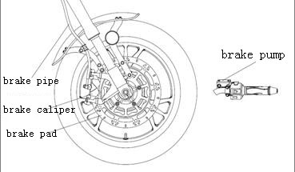
`8.Front brake system checking and adjustment
Brakes are an extremely important part of the rider's personal safety and should be checked and adjusted frequently.
[Check] (Figure 21)
1. The free stroke of the brake handle before measuring is: 5~10mm.
2. Measure the thickness of the front brake disc and the thickness of the brake lining.
3. Check the oil level in the oil cup; check if the brake caliper is normal; check the brake oil pipe and brake oil cup for oil leakage or crack; check the brake plate wear.
4. When operating the brake handle, feel that the handle pressure is insufficient, then there is air in the brake system; the air of the brake system should be completely discharged before it can be used normally; otherwise, the braking performance or the brake failure will be reduced. This work should be completed at the “Overdrive Store”.
[replace]
1. When the brake disc wears to the limit thickness of 3mm, it must be replaced; remove the front brake caliper and the front wheel, and then replace the brake disc.
2. When the brake lining wears to the limit thickness of 1.5mm, it must be replaced; remove the front brake caliper, remove the outer brake leaf spring and bolt on the brake caliper, and then replace the brake lining.
3. Replace with a new brake disc or brake friction disc. Do not drive immediately; firstly handle (hold) the front brake handle several times until the brake disc and the brake caliper are well engaged.

caveat:
1. It should be added: non-petroleum based brake oil of grade DOT3 or DOT4; different grades cannot be mixed;
2, brake oil is highly corrosive, do not splash on the surface of paint or plastic parts; if you drink it by mistake, it should be forced to spit out; if it gets on your eyes or skin, rinse it with plenty of water immediately, and ask your doctor for treatment;
3. The hydraulic disc brake works under high pressure. In order to ensure safety and reliability, the replacement time of the brake friction disc and brake oil cannot exceed the maintenance and repair period;
4. When the hydraulic disc brake system needs to be repaired, it can only be repaired by professional technicians.

9.Inspection and adjustment of the rear brake [check]（Fig 22）
1. The free travel of the brake pedal after measurement is: 10~20mm.
2. Measure the thickness of the brake disc and the thickness of the brake lining.
3. Check the oil level in the oil cup; check if the brake caliper is normal; check the brake oil pipe and brake oil cup for oil leakage or crack; check the brake plate wear.
4. When operating the brake pedal, feel that the pedal pressure is insufficient, then there is air in the brake system; the air of the brake system should be completely discharged before it can be used normally; otherwise, the braking performance or the brake failure will be reduced. For the maintenance, please let the professional technicians of the maintenance organization serve you.

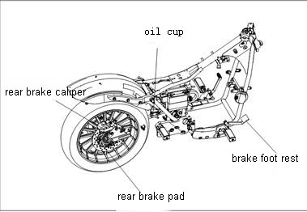
Fig 22 Rear brake check

[Adjustment and replacement]
For the maintenance, please let the professional technicians of the maintenance organization serve you.
1. When the brake disc wears to the limit thickness of 3mm, it must be replaced;
2. When the brake friction plate is worn to the limit thickness of 1.5mm, it must be replaced; remove the rear brake caliper, remove the outer brake leaf spring and bolt on the brake caliper, and then replace the brake friction plate.
3. When replacing the rear brake disc, the chain and the rear brake should be removed, then the rear axle nut and the rear axle should be removed, the rear wheel removed, and the rear brake disc replaced.
caveat:
1. After adjusting the rear brake system, it is necessary to test the vehicle;
2. After the pedal is braked several times, then release the brake pedal and rotate the rear wheel to check whether it can rotate freely.
3. After the adjustment of the rear brake system is completed, confirm that the brake pedal is returned flexibly and ensure that the braking force is normal;

10.Battery maintenance
[battery model]
Model: DB9-BS
Capacity: 12V 9Ah
Standard charging 0.9A × 5 ~ 10 hours
Maintenance-free battery, no need to check the amount of electrolyte or add distilled water. The new battery cannot be removed after the first addition of the electrolyte.

[Removable battery] (Figure 23)
Dismantle:
1. Use a No. 5 Allen key to remove one screw of the right guard and remove the right side guard of the seat cushion;
2. Remove the negative lead (━) first;
3. Remove the positive lead (╋) afterwards;
4. Remove the rubber fastening tape and remove the battery.
installation:
1. The order of installation is the reverse of the removal procedure.
2. Install the positive lead (╋) first, then install the negative lead (━), and
Make sure that the positive and negative terminals are not loose, and the positive and negative terminals cannot be reversed. Reverse connection Figure 23
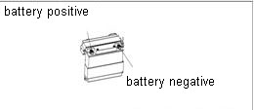
Will damage electrical parts.。

图23 蓄电池位置

Fig 23

[battery charging]
1. Remove the right side guard from the right side of the car.
2. Remove the battery cable tie, remove the positive and negative wires, and take out the battery.
3. Connect the charger wire and ensure that the charging current is 1/10A of the battery capacity. For example, charge the battery with a capacity of 10Ah, and its charging current is 1 amp.
4. Please contact your dealer for detailed instructions on the charger.
[Battery inspection and maintenance]
1. When used frequently, the motorcycle charging system automatically charges the battery. If the motorcycle is used occasionally or when the motorcycle is used for a short period of time, the battery may be low. The battery will generate its own discharge, and its own discharge speed will vary with the type of battery and the ambient temperature.
2. When the motorcycle is not used for a long time, the battery must be removed and stored after charging, and the battery should be charged periodically;
3. The battery positive (╋) and negative (━) terminals should be cleaned regularly.
4. When replacing the battery, use the same type and battery of the same specification.

Danger:
1. It is forbidden to open the battery sealing strip, otherwise it will damage the battery. Can not install ordinary batteries, otherwise it can cause the electrical system to work abnormally. Under certain conditions, the battery electrolyte will produce flammable gas. It must be kept away from sparks, open flames and cigarettes. The battery should be charged to ensure adequate ventilation.
2. The battery contains sulfuric acid. In case of accidental skin or eye contact with the electrolyte, it will cause severe burns. Rinse immediately with clean water and seek medical attention immediately. Therefore, wear protective clothing and goggles to work. The electrolyte is also a toxic chemical. If you accidentally swallow the electrolyte, you must drink plenty of water or milk, then drink magnesium oxide emulsion or vegetable oil, and seek medical attention immediately.
3. Battery terminals, terminals and related components contain lead or lead compounds that can harm your health if lead or lead compounds enter the blood system. You must wash your hands after handling any leaded parts.
4. The battery must be stored in a place that is out of reach of children.
5. The battery contains toxic substances, including sulfuric acid and lead. It can cause harm to people and pollute the environment. Used batteries must be disposed of or recycled in accordance with local laws. Can not be discarded like ordinary household garbage.

[Fuse replacement]
The circuit system has a total of three blade fuses, 20A fuse 2PCS and 15A fuse 1PCS. Located under the seat cushion.
If the fuse is often blown, the circuit system is short-circuited or overloaded. Please let the professional technician of the maintenance unit serve you.
When replacing the fuse, first unplug the old fuse and plug in the spare fuse.
Warning:
The ignition switch and electrical switch must be turned off before checking or replacing the fuse to prevent a short circuit. Never use a fuse that is different from the rated current. Otherwise, the vehicle's electrical system may be damaged or cause a fire. It may also cause the light to fail to open or the engine to fail at night or during driving.

11.Engine water cooling system use and maintenance instructions
[cooling system]（Fig 24）
The cooling system prevents the engine from overheating and properly uses and maintains the cooling system to extend the life of the engine.
The radiator is located at the front of the engine and the radiator should be regularly cleaned of dust and dirt depending on the condition of the road you are driving.
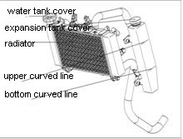

Fig 24 Cooling system

[Cooling system]
The coolant has five characteristics of anti-corrosion, anti-cave, high boiling point, anti-scaling and anti-freezing.
The coolant is usually mixed with a concentrated antifreeze and soft water (pure water or distilled water) in an appropriate ratio. Please adjust the concentration to the local minimum temperature. Generally, when the concentration is 40%~50%, the antifreeze function is best.
It is recommended that you use a direct coolant for aluminum alloy engines that has been formulated at the factory and contains antifreeze, rust inhibitor, foam inhibitor and traces of silicate, and is indicated on the container. Ambient temperature.
[Check coolant capacity]
The total amount of coolant in the cooling system is approximately 2000ml
1. Park the motorcycle with a single support on a level surface.
2. Check the coolant level while the engine is cooling. The liquid level of the coolant should be between the upper and lower scale lines.

[Add a small amount of coolant]
If the coolant in the auxiliary tank is at or below the lower scale line, please add special coolant to the upper scale line.

[addition method]
1. Park the motorcycle with a single support on a flat surface until the engine is cold; otherwise the heat will cause burns to the skin;
2. Use the No. 5 Allen key to remove the two screws of the auxiliary tank cover and extract the auxiliary water tank from the shield;
3. Open the rubber cover of the auxiliary tank and add the coolant to the upper scale line position;
4. Close the rubber cover of the auxiliary tank, put on the auxiliary tank cover, and put it back.

Danger:
1. Ethylene glycol antifreeze is an organic solvent that is toxic and corrosive. Do not spill on the surface of rubber products or paint parts during use, and do not touch human skin. If it is accidentally splashed on rubber products, paint surfaces or human body, rinse immediately with water.
2. When servicing the engine, if you need to loosen the cylinder nut, please drain the coolant first to prevent the coolant from entering the crankcase.
3. Since the boiling point of the antifreeze is higher than that of pure water, the temperature of the radiator should not be opened when the temperature of the engine is not lowered (60 °C) after normal operation or parking, so as not to burn the body.

11.Vehicle cleaning and storage
1. When the coolant is not in use, it should be stored in a special sealed container.
2. It should be placed in a cool and dry place. The coolant is a toxic liquid and must be kept out of contact with children.
3. Note that the coolant should be strictly protected from contamination by petroleum products, and it is not possible to mix or store two different brands of coolant.
12.Vehicle cleaning and storage
[vehicle cleaning]
1. The motorcycle should be cleaned regularly so as to detect the damage, wear or oil leakage of the vehicle in time.
2. When cleaning, wait for the engine to cool down and rinse with clean water. After cleaning, dry the motorcycle and start the engine, let it run for a few minutes; lubricate the chain with lubricating oil; check the brake before driving on the road, and the front and rear brakes should be normal.
3. Parts that cannot be sprayed with high-pressure water: headlights, turn signals, ignition switch locks, electrical switches, meters, electrical parts and circuits, batteries, air filters, hubs, exhaust pipe outlets, under the fuel tanks, and engines Cylinder head, etc. These parts are best scrubbed with a rag.
4. The braking performance may be reduced after cleaning. It must be tested by riding and can be used after adjustment and recovery.
[vehicle storage]
After the motorcycle is used on the same day, it should be stored in a safe place with dryness, small temperature difference and good ventilation. If it is stored for a long time (more than 30 days), the necessary repairs should be carried out before storing the motorcycle; otherwise, the problem of repairing may be forgotten when using it after the end of storage. Long-term storage (more than 30 days) In addition to the above maintenance, it should also be maintained according to the following requirements:
1. Wash and dry the motorcycle, and wax the surface of the entire car.
2. Discharge the fuel from the fuel tank and spray the rust inhibitor into the fuel tank.
3. Thoroughly drain the oil and re-add new oil to the crankcase.
4. Remove the spark plug and inject a small amount (15-20 ml) of lubricating oil into the cylinder; then reinstall the spark plug, open the ignition switch lock, and press the start button for 2-3 seconds to distribute the oil evenly on the cylinder wall.
5. Remove the battery, remove the rust on the terminals and wiring connectors, and store in a well ventilated, dry, cool, and away from direct sunlight.
6. Inflate the tire to the specified air pressure and place the motorcycle above the block so that the front and rear wheels leave the ground. If the tire pressure is too low, the tire will age prematurely and crack.
7. Cover the air inlet of the air filter and the exhaust port of the exhaust muffler with a rag containing new engine oil to prevent moisture from entering.
8. Cover the motorcycle with a breathable material and store it in a safe place with dryness, small temperature difference and good ventilation.

[Use after storage]
1. Remove the motorcycle cover and clean the motorcycle.
2. Detect the voltage of the battery. If the voltage is below 12.8V, it must be charged at a low speed before installing the battery.
3. Remove the rust inhibitor from the fuel tank and add new fuel.
4. Test the motorcycle in a safe place and check if the performance of the motorcycle is normal
13.Vehicle life and vehicle handling
[Vehicle life]
The service period of the vehicle shall be in accordance with the regulations of the traffic management department or the local vehicle management office.
[vehicle processing]
1. Disposal of waste lubricating oil: The waste lubricating oil under the replacement of motorcycles should be packed in plastic drums and handed over to the recycling company for disposal. You can't arbitrarily discharge waste lubricating oil, otherwise it will cause damage to the environment such as the site, soil and water source.
2. Disposal of used batteries, bulbs, exterior parts, filter elements, tires, iron parts, aluminum parts, etc.: These scrapped parts should be sorted and recycled. You can't discard it at will, and you can't dump the dilute sulfuric acid in the battery to cause harm to people or pollute the environment.
3. After the vehicle is scrapped, please dispose of it according to the vehicle management regulations of the traffic management department or the local vehicle management office.
14.Motorcycle related adjustment data
Front (hand) brake free travel 5 ~ 10mm Free clearance of throttle handle: 2 ~ 6mm
Rear (foot) brake free travel 10 ~ 20mm Free travel of the clutch: 5 ~ 10mm
Chain slack: 10 ~ 20mm Spark plug clearance: 0.6 ~ 0.7 mm
Intake and exhaust valve clearance: 0.08～0. 12 mm Rear shock absorbing fastening bolt torque value: 30～40 N•m
Handle tightening bolt torque value: 4~6N•m Flat fork shaft tightening nut Torque value: 70～90 N•m
Front wheel axle tightening nut Torque value: 70～90N•m Steering system tightening nut Torque value: 50～70 N•m
Rear wheel axle tightening nut Torque value: 70～90 N•m
Front shock absorption and upper connecting plate fastening bolt torque value: 10~14N•m
Front shock absorption and direction column fastening bolt torque value: 20~25 N•m
Torque value of engine suspension fastening nut: M8: 18~25 N•m, M10: 30～40 N•m

15.Main technical parameter list
Model (project) |  | BD250-2 |  | BD400 | BD400-C
whole  vechile  Reference  number | name of the manufacturer  Vehicle model (commercial name)  Vehicle Brands  Vehicle Type  Vehicle Identification Number  Approved manned  Steering Type  Gear form  Brake form  Brake operation mode  Clutch form  Clutch operation mode  Startup mode  Length × width × height  Wheelbase  Minimum ground clearance  Vehicle kerb quality  Maximum load mass  Fuel tank volume  Number of tires  Front wheel specification  Rear wheel specification | Zhejiang changling Benjian Vehcile Co.,Ltd
whole  vechile  Reference  number |  | FUN2  OVERDRIVE  LBDPDNLAxxxxxxxxx  2 persons  Streeing stem  6 gears  Front wheel: disc rear wheel: disc  Front wheel: hand brake rear wheel: foot brake  Oil bath multi-piece  Hand operation  electric  2130×810×1100（mm）  1460（mm）  160（mm）  179kg  150kg  19L  2  120/80-17 M/C  140/70-17 M/C | COUGAR  brand (OVERDRIVE)  2-wheels vehcile  LBDPDSLAxxxxxxxxx  2（Driver and passager）  Handle bar  6 gears  Frontwheel:disc rear wheel:disc  Front wheel: hand brake rear wheel: foot brake  Oil bath multi-piece  electric  2130×810×1100（mm）  1460（mm）  160（mm）  184kg  150kg  19L  2  120/80-17 M/C  140/70-17 M/C |  | RAPTOR  brand (OVERDRIVE)  2-wheels vehcile  LBDPDSLAxxxxxxxxx  2（Driver and passager ）  Handle bar  6 gears  Frontwheel:disc rear wheel:disc  Front wheel: hand brake rear wheel: foot brake  Oil bath multi-piece  electric  2160×810×1160（mm）  1460（mm）  160（mm）  188kg  150kg  19L  2  120/80-17 M/C  140/70-17 M/C
Electricity  Parts Set | Ignition type  Spark plu  headlight  turn light  tail light/brake light  fuse  Battery type | ECU  TORCH D8RTI  12V 35W/35W  12V LED  12V LED  20A（2个）、15A(1个）  12V 9Ah | ECU  TORCH D8RTI  12V 35W/35W  12V LED  12V LED  20A（2个）、15A(1个）  12V 9Ah |  | ECU  TORCH D8RTI  12V 35W/35W  12V LED  12V LED  20A（2个）、15A(1个）  12V 9Ah
engine | engine  Engine type  Compression ratio  Actual displacement  Max net power  Max torque  bore×stroke  Idling  Engine lubrication oil  Lubrication oil  fuel  Spark plug distance | vertical、twin-cylinder、4-sstroke 、water-cooling  BD253MM  10.5：1  248ml  17.9kW/7500 r/min  26N·m/5000 r/min  53.5mm×55.2mm  1500r/min±150 r/min  SG 15W-40  change:2.3L repair:2.1L  95# fuel  0.6～0.7 mm | vertical、twin-cylinder、4-sstroke 、water-cooling  BD267MQ  11.2：1  389ml  27kW/9500 r/min  28N·m/8000 r/min  67mm×55.2mm  1500r/min±150 r/min  SG 15W-40  change:2.3L repair:2.1L  95#fuel  0.6～0.7 mm |  | vertical、twin-cylinder、4-sstroke Water-cooling  BD267MQ  11.2：1  389ml  27kW/9500 r/min  28N·m/8000 r/min  67mm×55.2mm  1500r/min±150 r/min  SG 15W-40  change:2.3L repair:2.1L  95#fuel  0.6～0.7 mm
change  speed  ratio | Primary speed ratio  First gear ratio  Second gear ratio  Third gear ratio  Four gear ratio  Five speed ratio  Six speed ratio  Final speed ratio | 0.309  0.414  0.654  0.846  0.958  1.1  1.238  0.368 | 0.309  0.414  0.654  0.846  0.958  1.1  1.238  0.326 |  | 0.309  0.414  0.654  0.846  0.958  1.1  1.238  0.326
performance | Highest speed  Gradeability  Fuel consumption | 130km/h  ≥20°  ≤2.9L/100km | 150km/h  ≥20°  ≤3.4L/100km |  | 150km/h  ≥20°  ≤3.4L/100km

16.Motorcycle’s fault and caused reason
phenomenon | Parts position | Caused reason | solution
Can’t start | Fule system | no fuel in the tank | refuel
Can’t start | Fule system | - Oil pump blocked or damaged, poor fuel quality | Clean or replace
Can’t start | Ignition system | - Spark plug fault: carbon accumulation, use time is too long | Inspect or replace
Can’t start | Ignition system | Spark plug cap failure: poor contact or burn  Ignition coil failure: poor contact or burn out | Inspect or replace
Can’t start | Ignition system | CDI failure: poor contact or burnout | Inspect or replace
Can’t start | Ignition system | Trigger coil failure: poor contact or burnout | Inspect or replace
Can’t start | Ignition system | Stator failure: poor contact or burnout | Inspect or replace
Can’t start | Ignition system | Each cable failure: poor contact | Check and adjust
Can’t start | Cylinder pressure system | Starting mechanism failure: wear or damage | Inspect or replace
Can’t start | Cylinder pressure system | Intake and exhaust valve, valve seat failure: fuel contains more glue or use for too long | Inspect or replace
Can’t start | Cylinder pressure system | Cylinder, piston, piston ring failure: fuel contains gel or wear | Inspect or replace
Can’t start | Cylinder pressure system | Air intake pipe leakage: too long use time | Inspect or replace
Can’t start | Cylinder pressure system | Gas distribution timing failure | Inspect or replace
Low- power | Valve piston | Excessive carbon deposits in intake and exhaust valves and pistons: poor fuel quality and poor oil quality | Repair or replace
Low- power | clutch | Clutch slippage: poor oil quality, long service life, overload | Adjust or replace
Low- power | cylinder、ring | Cylinder block and piston ring wear: poor oil quality and long service life | Change oil
Low- power | Brake system | Brake separation is not complete: brake is too tight | adjust
Low- power | chain | Chain too tight: improper adjustment | adjust
Low- power | Engine | Engine overheating: The mixture is too rich or too lean, and the oil and fuel quality are poor.  Obstruction, etc. | Adjust or replace
Low- power | Spark plug | Improper spark plug gap, normal 0.8-0.9 mm | Adjust or replace
Low- power | Intake pipe | Air intake pipe leakage: too long use time to adjust or replace | Adjust or replace
Low- power | Cylinder head | Cylinder head or valve leak | Check or replace
Low- power | Electrical system | Electrical system is faulty | Check or repair
Low- power | Air cleaner | Air filter blockage | Clean or adjust
Headlight,taillight are not on | cable | Poor line connection | adjust
Headlight,taillight are not on | L&R switch | Poor contact or damage to the switch | Adjust or replace
Headlight,taillight are not on | headlight | Lamp, lamp holder check | Adjust or replace
Headlight,taillight are not on | regulator | Regulator check: poor contact or burnout | Adjust or replace
Headlight,taillight are not on | magmotor | Magneto motor coil inspection: poor contact or burnout | Adjust or replace
Horn not work | battery | No power | Adjust or replace
Horn not work | Left swtich | Checking button | Adjust or replace
Horn not work | cable | Poor line contact | Adjust or replace
Horn not work | horn | Horn damage | Adjust or replace

Listed above are common faults in motorcycles. If your motorcycle is faulty, please go to the designated maintenance unit for inspection and repair.
MT05 Fault code table
Fault code | Description
P0107 | Inlet pressure sensor open or shorted to ground
P0108 | Intake pressure sensor shorted to power
P0112 | Intake air temperature sensor shorted to ground
P0113 | Intake pressure sensor open or shorted to power
P0117 | Cooling/cylinder temperature sensor shorted to ground
P0118 | Cooling/cylinder temperature sensor open or shorted to power
P0122 | Throttle position sensor open or shorted to ground
P0123 | Throttle position sensor shorted to power
P0131 | Oxygen sensor (one cylinder) shorted to ground
P0132 | The oxygen sensor (one cylinder) is shorted to the power supply
P0031 | Oxygen sensor heater shorted to ground
P0032 | Oxygen sensor heater shorted to power
P0201 | First cylinder nozzle failure
P0202 | Second cylinder nozzle failure
P0230 | Oil pump (relay) open or shorted to ground
P0232 | Oil pump (relay) shorted to power supply
P0336 | Crankshaft position sensor has interference
P0337 | Crankshaft position sensor has no signal
P0351 | First cylinder ignition coil failure
P0352 | Second cylinder ignition coil failure
P0505 | Idle speed control failure
P0562 | System voltage is too low
P0563 | System voltage is too high
P0650 | Fault light failure
P1693 | Tachometer shorted to ground
P1694 | Tachometer shorted to power supply

Listed above are the common fault codes for motorcycles. If your motorcycle is faulty, please go to the designated maintenance unit for inspection and repair.
Remember: You can't handle motorcycle faults yourself, otherwise it will cause safety hazards or safety accidents. If you handle the motorcycle malfunction yourself, it is your responsibility to cause a safety accident.

17. Electrical system diagram

